WI-12 Void an unpaid invoice in Ledgerly
Example work instruction for Northwind, a made-up company, from https://stepkeep.app/guides/work-instructions. Ledgerly is a demo app; customer names are blurred.
Trigger | A ticket says the customer cancelled and has not paid.
Scope | Invoices with the status Draft, Awaiting payment or Overdue.
Not for | Paid invoices. They get a refund (WI-13 Refund a paid invoice).
Prerequisites | The Finance role in Ledgerly, the invoice number, the ticket open.
Owner | Billing lead
Revision | Rev. 1 · 4 October 2026 · first version
Parent SOP | Billing corrections, step 3

Actions
No. | Action | Screenshot
1 | In Search invoices, type the invoice number from the ticket. Only that invoice stays in the list. | 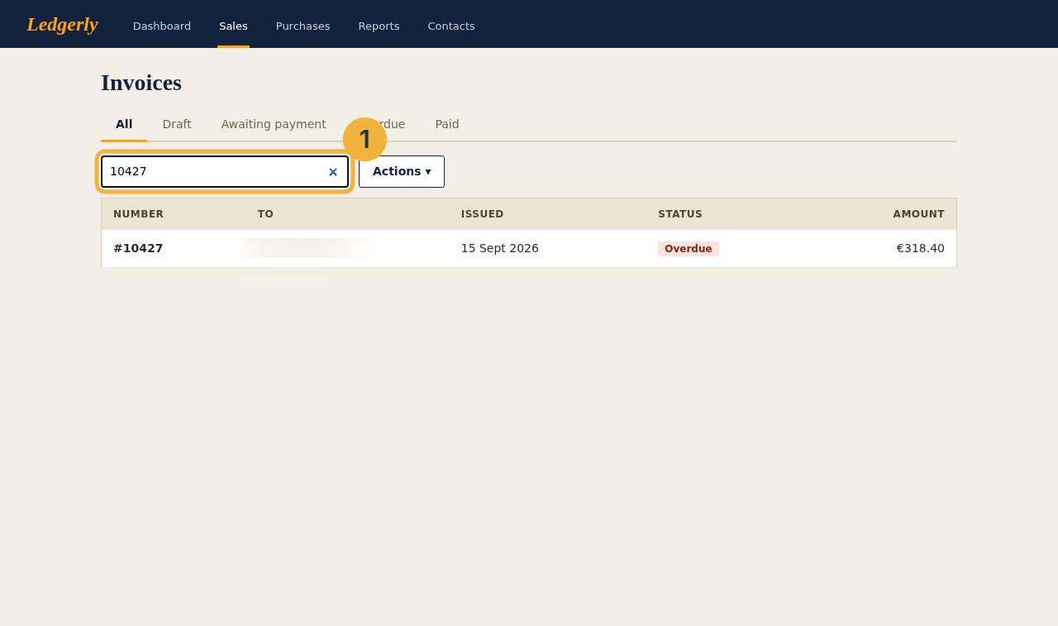
2 | Click the invoice's row. The row is highlighted.
3 | Click Actions. A menu opens.
4 | Choose Void invoice. | 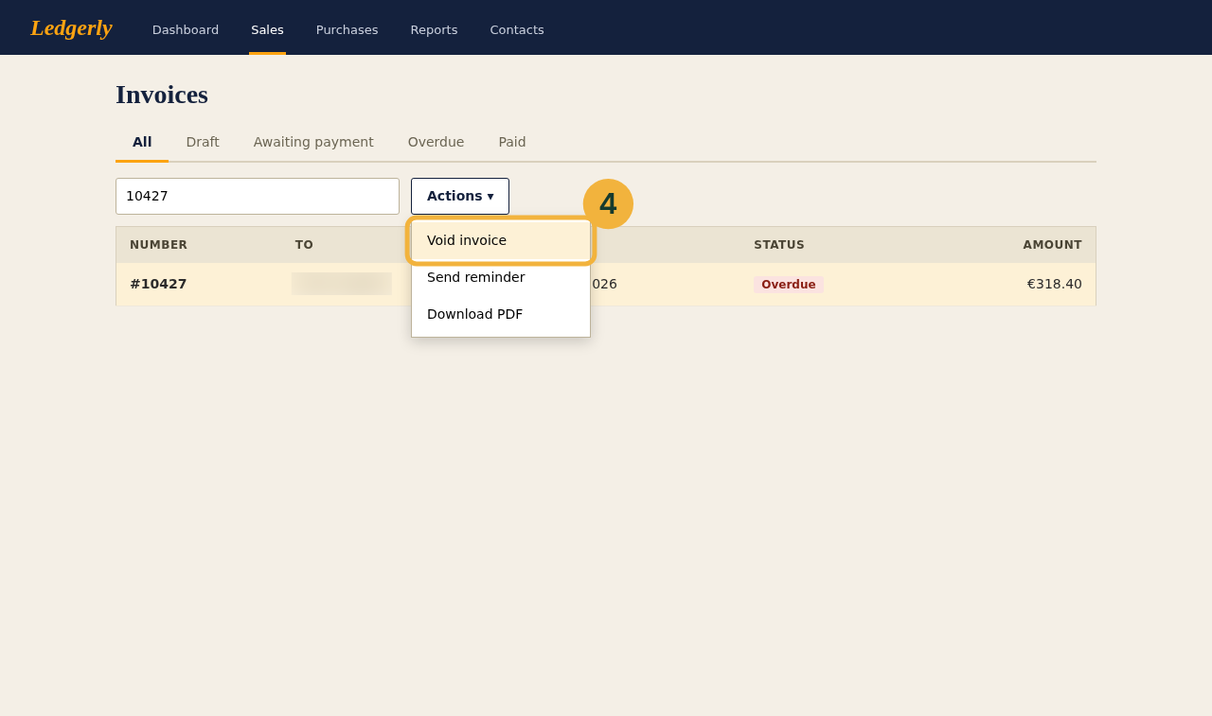
5 | Check that the notice Invoice #… voided appears above the tabs and that the status reads Void, struck through. | 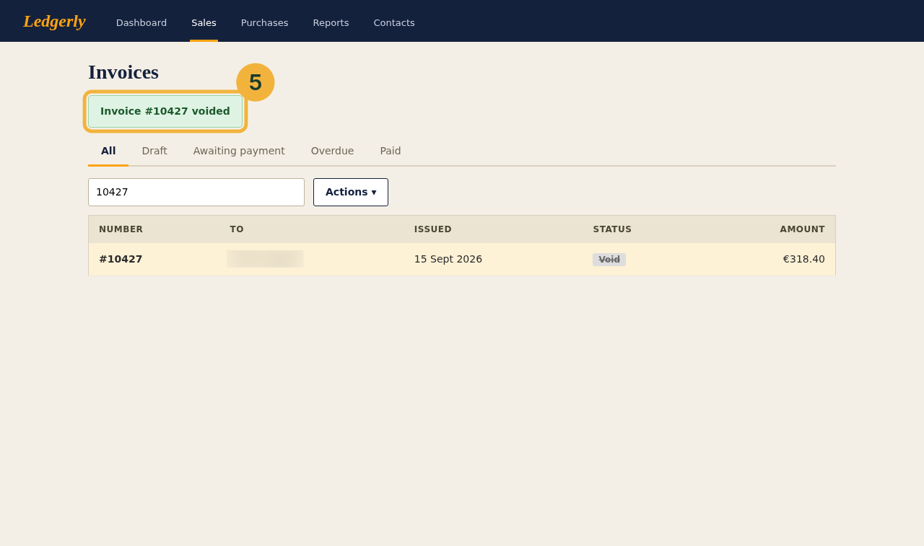

Expected result
The invoice reads Void. Reply in the ticket with the invoice number and close it.

If this happens
The red notice is Paid and cannot be voided: issue a refund instead means the customer has paid. Stop, change nothing, and follow WI-13 instead.
