Northwind support training manual · Version 1.0 · Owner: Lena, support lead · Checked 4 October 2026

Module 1: Orders and refunds
Objective | After this module the trainee can export last month's paid orders, refund a paid order within the 200 EUR limit, and void an unpaid invoice instead of refunding it.
Tasks | 1.1 Export last month's paid orders · 1.2 Refund a paid order · 1.3 Void an unpaid invoice
Before you start | Support role in Cartwell (orders), Paynest (payments) and Ledgerly (invoices). Practise in the test environment with test data, not in the live one.
Time | 40 minutes: 25 for the tasks, 15 for the check
Screenshots: real recordings of a demo shop admin made for these guides, in its test data. Paynest, Ledgerly and Cartwell are demo tools, not real products. Customer names are blurred.

Task 1.1: Export last month's paid orders
When | First working day of the month, for the accountant's monthly close.
Work instruction | "Export last month's paid orders to CSV", Support folder
# | Step
1 | In Cartwell, open Orders. In Date range, select Last month: the previous calendar month, not Last 30 days.  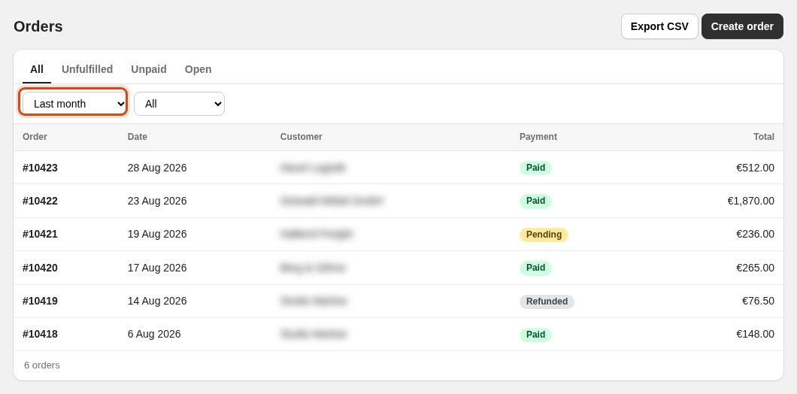
2 | In Status, select Paid. The list shows paid orders only.  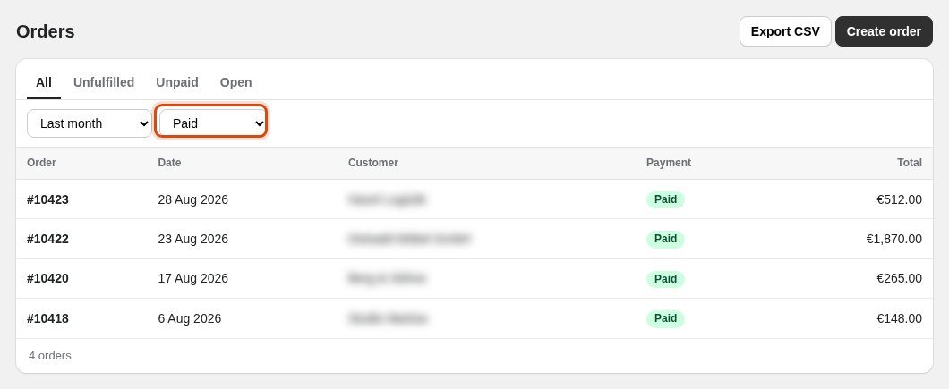
3 | Click Export CSV. Send the file to the accountant.  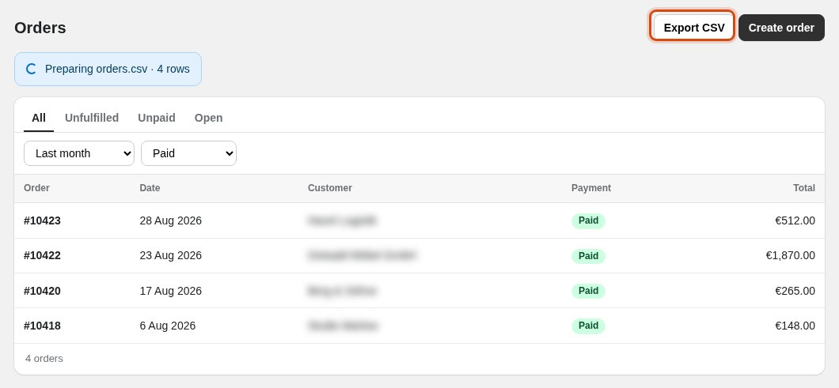
Expected result | A banner at the top reads "Preparing orders.csv" with the number of rows.
If it fails | The list still shows Pending orders: the Status filter is not set. Set both filters first, then export again.

Task 1.2: Refund a paid order
When | A customer asks for a refund in a support ticket. Paid orders only. Up to 200 EUR, support refunds alone; above 200 EUR, finance approves in the ticket first.
Work instruction | "Issue a refund on a paid order", Support folder
# | Step
1 | In Paynest, in Search orders, type the order number from the ticket, for example 10430.  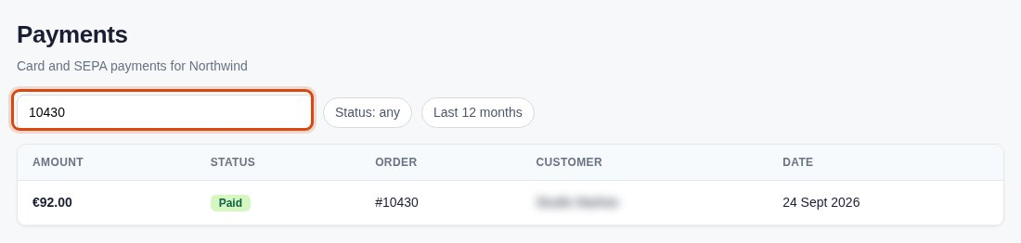
2 | Click the order's row. Check that customer and amount match the ticket and the status is Paid. Above 200 EUR, go on only if finance has approved the refund in the ticket.  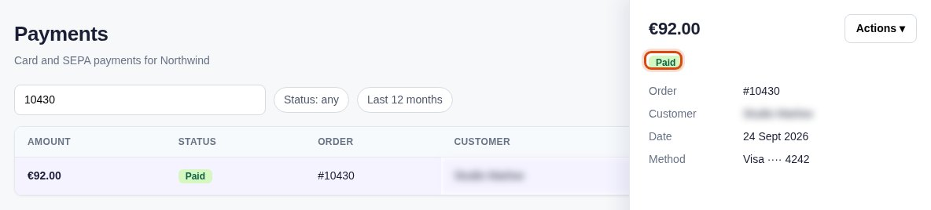
3 | In the details, select Actions > Issue refund.  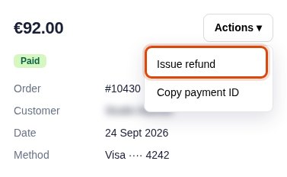
4 | In Refund note, type the reason from the ticket, for example "Duplicate charge".  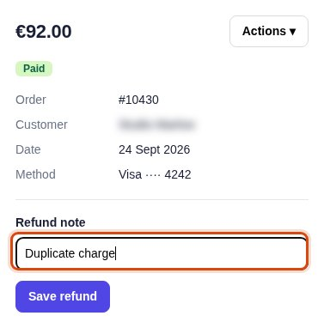
5 | A saved refund cannot be taken back. Check the order number once more, then click Save refund.  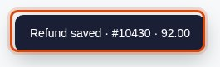
Expected result | "Refund saved" appears at the bottom left with the order number and the amount.
If it fails | The status is not Paid: stop. An unpaid invoice is voided (task 1.3), not refunded. Above 200 EUR with no approval in the ticket: stop and ask finance in the ticket.

Refund or void
Paid: refund it in Paynest (task 1.2). Overdue or Draft: nothing was paid, so void the invoice in Ledgerly (task 1.3).

Task 1.3: Void an unpaid invoice
When | An invoice was sent in error and is not paid yet (status Overdue or Draft).
Work instruction | "Void an unpaid invoice", Support folder
# | Step
1 | In Ledgerly, in Search invoices, type the invoice number, for example 10427.  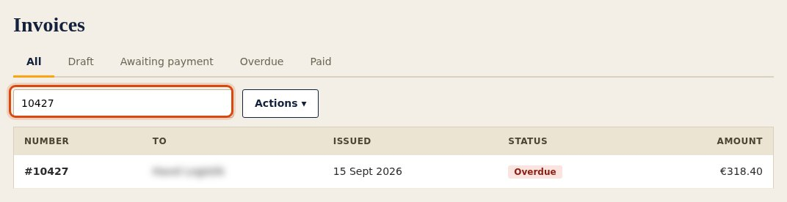
2 | Click the invoice's row and check its status. If it is Paid, stop and use task 1.2.  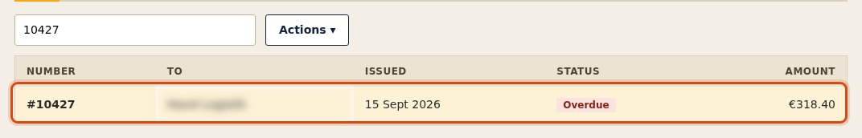
3 | Select Actions > Void invoice.  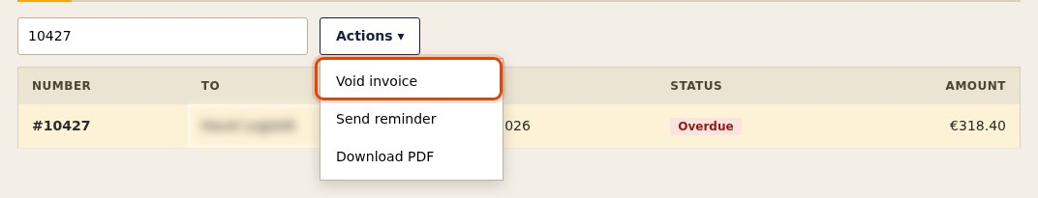
4 | Tell the person who asked that the invoice is void, with the invoice number.  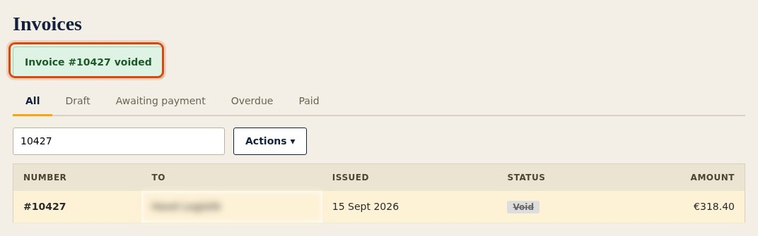
Expected result | A green notice reads "Invoice #10427 voided".
If it fails | The status is Paid: do not void it. Refund the order in Paynest instead (task 1.2).

Check: Module 1
On the test environment, without the manual open. The trainer watches and fills in the last column.
# | Do this on test data | A correct result looks like | Done
1 | Send the accountant last month's paid orders. | Filters read Last month and Paid; the banner reads "Preparing orders.csv" with the row count. | [ ]
2 | A ticket asks for a refund of order 10430 (92.00 EUR), reason "Duplicate charge". Handle it. | Status Paid and amount checked first, then the refund saved for 10430 with the note "Duplicate charge". | [ ]
3 | A ticket asks for a refund of order 10428 (1,240.00 EUR); finance has not approved it. | No refund saved; the trainee asks finance for approval in the ticket. A refund here is a fail. | [ ]
4 | Invoice 10427 was sent in error. Handle it. | The trainee checks the status, sees it is not Paid and voids it: "Invoice #10427 voided". A refund here is a fail. | [ ]
Pass: all four done without the manual open. Checked by: ________ Date: ________

